FEAR - DESTRUCTION - WALL BREAK EVENT

1 Introduction 2
2 The Walls 2
2.1 3 Easy Pieces 2
2.2 The Wall Guts 3
2.3 Debris & Impulse 3
2.4 The SpecialFX 3
2.5 The CommandObject 4
2.6 Finishing It Up 5

Introduction

We came up with a couple of wall break events that we used in XP-1 that basically had enemies busting through walls to get at the player. Here we’ll cover the elements that go into one of the simpler wall break events. There is an example world to accompany this, and you might want to have it open while you read through this explanation. The example world for this tutorial is called, Destruction_BreakableWall_01. Load up this level, run it, and then step up onto the gray checkered platform in front of you to watch the event.

There are two other example worlds for you to examine that contain more complex wall break events. The other example worlds are:

Destruction_BreakableWall_02
Destruction_BreakableWall_03

With most of the wall break events, we started the scene with a perfect, pristine version of the wall section, and once the event was triggered, we would hide the perfect wall section and unhide a broken version of that wall that was placed in the same spot. For the example map that goes along with this tutorial, the objects that will be covered are all located in the WORK/BustWall folder in the node tree.

The Walls

3 Easy Pieces

There are 3 main parts that comprise the wall break event (along with several minor ones).

- Wall is a WorldModel that is the perfect pristine version of the wall BEFORE it gets broke.
  - It has two flat single-sided planes that face in opposite directions and are lined up perfectly with the surrounding walls.
  - The textures on these planes are the same textures as on the walls that surround them and their textures are lined up with the textures that surround them as well. So, until broken, the player would not be able to see anything wrong with that wall section at all.
  - This section starts “unhidden”. And to ensure that it blocks any physical items that might get thrown or pushed into it before it breaks, you’ll want to set its physics collision box.
  - Since it’s really a very simple boxy shape, you can get away with setting the WorldModel’s BoxPhysics to True and its PhysicsShape to OBB.

- Wall_Broke is a WorldModel that starts “hidden” and it represents the BROKEN version of the wall.
  - When the event is started, the Wall will get “hidden” and the Wall_Broke will get “unhidden.”
  - When combined with the falling wall pieces and debris, this fools the player into thinking that the wall has been busted through from the other side. In this particular case, my Wall_Broke was a fairly complicated combination of several jagged brushes, so using BoxPhysics would have been a bad idea. I chose to go with no physics collision on this as the hole in the middle was much larger than the shell that was left. Although I could have went the route of using several PhysicsShapeOBBs placed around the edges.

- Wall_Fall01 is a RotatingWorldModel that starts “hidden” and that has a BSP brush that is in the general shape of the hole in the Wall_Broke WorldModel.
  - This will get “unhidden” at the same time as the Wall_Broke and immediately set to start its rotation. This rotating wall section gives the impression of a section of the wall being knocked in and over.

The Wall Guts

We wanted the “inside” of the broken wall to have a couple of broken 2 by 4’s and rough cement edging around the area where it looked like the wall broke loose. We knew these items would be between the walls and would not be able to be seen when the wall was “unbroken” so they were not put into a WorldModel. I simply put kept them as plain BSP brushes and put them in their own folder (Inside) in the node tree to keep them organized.

Debris & Impulse

We wanted chunks of debris to appear to be blasted outward when the wall got broken, so we set up several physical debris objects that would start out NON-RigidBody and “hidden”. Only when the wall break itself was triggered would the debris be “unhidden” and be set to go physical with the RigidBody setting. We placed these chunks of debris in the air and set up a PhysicsImpulseDirectional that was targeted to all of the debris and set its rotation to the direction we wanted the debris to be blasted. As soon as the debris was made visible and the pieces were turned physical with RigidBody, we set off the PhysicsImpulseDirectional which caused the debris to appear to be blasted out from the breaking wall. We put all of the debris chunks into their own folder (PhysicsObjects) in the node tree to keep them organized.

The SpecialFX

To help cover up the hiding and un-hiding of the different wall sections and simply to make the wall break look more cool and realistic, many SpecialFX objects had to be spread out around the perimeter of where the wall break would be. We put all of the SpecialFX objects into their own folder (PFX) in the node tree to keep them organized. And of course all of these SpecialFX had to be triggered at different times through the scripting.

The effects used for this event were:
- Shake_Severe_1s. Used for the vision shake when the wall gets blasted outward.
- Impact_Nade. I used this effect for the dust and smoke that it puts out, plus it has a great explosion sound for the explosion that blows the wall out.
- Grit. A nice dust cloud for the air around the breakage.
- FallingDust_Fine. A nice dust cloud for the air around the breakage.
- Ball_Exp_2. A nice dust cloud for the air around the breakage.

The CommandObject

This is the object that would be called on to start the whole sequence. We went with a total of 4 timelines.

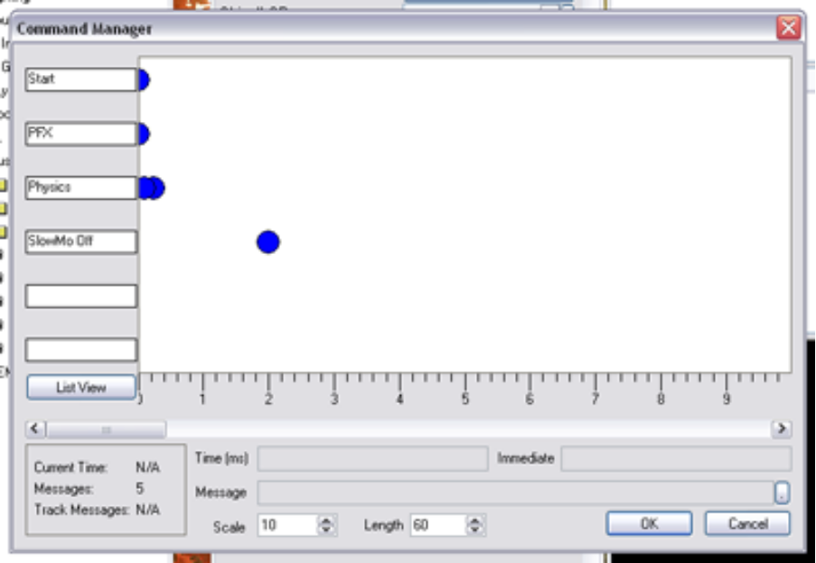

The Start timeline had 1 event at 0 seconds.

This event had the following code:
msg player (slowmo on Default);
msg Wall (HIDDEN 1);
msg Wall_Broke (HIDDEN 0);
msg Wall_Fall01 (HIDDEN 0);
msg Wall_Fall01 on;

What I did there was to force the player into the Default slowmo (just for cool factor), I hid the Wall, I UN-hid the Wall_Broke and Wall_Fall01 and then turned on Wall_Fall01 (which was a RotatingWorldModel) which made it appear to fall forward.

The PFX timeline had 1 event at 0 seconds that controlled all of my SpecialFX.

The code for this event was:
msg PFX01 on;
msg PFX02 on;
msg PFX03 on;
msg PFX04 on;
msg PFX05 on;
msg PFX06 on;
msg PFX07 on;

The Physics timeline had 2 events.

The 1st was at 100 milliseconds and contained the code:
msg PO_01 (HIDDEN 0);
msg PO_02 (HIDDEN 0);
msg PO_03 (HIDDEN 0);
msg PO_04 (HIDDEN 0);

The 2nd was at 250 milliseconds and contained the code:
msg PO_01 (RIGIDBODY 1);
msg PO_02 (RIGIDBODY 1);
msg PO_03 (RIGIDBODY 1);
msg PO_04 (RIGIDBODY 1);
msg PID on;

The scripting in the 1st event was delayed just long enough to allow the hiding and un-hiding of the wall sections and what it did was to un-hide all of the physical debris pieces.

The scripting in the 2nd event was delayed to start just after the debris pieces had a chance to become un-hidden. It turned the pieces physical by setting their RigidBody flags to 1 (true), and it turned on the PhysicsImpulseDirectional that would blast the pieces outward.

The SlowMo Off timeline had one event at 2 seconds.
msg player (slowmo off);

This simply turned off the player’s forced slowmo after 2 seconds

Finishing It Up

That’s basically it for this Wall Break Event. You can make it as complicated or as simple as you need. Of course you’ll also need to script the entrance of your enemies who broke through the wall, or whatever it was that caused the break. The way in which you could use breakable walls are endless. With enough modification, you could change out this basic design and have plaster that falls away from walls in chunks when taking damage or anything else you can imagine. Destruction is good!

